ORDINANCE | 0-2024-14
 | CITY OF KEENE
In the Year of Our Lord Two Thousand and |  |  | Twenty Four
AN ORDINANCE | Relating to Winter Maintenance Parking Restrictions
Be it ordained by the City Council of the City of Keene, as follows:

That the City Code of the City of Keene, New Hampshire, as amended, is hereby further amended by removing Sec. 94-95 (a) “Snow maintenance period” in its entirety and replacing it with the following bolded text:

- Winter maintenance period.
  - The Public Works Director or their designee (“Director”) shall be empowered to declare a Winter Weather Parking Ban whenever the existing conditions warrant or weather forecasts predicting snowfall, sleet, freezing rain, or other inclement weather indicate that the execution of necessary highway maintenance activities will require the prohibition of parking on city streets or municipal lots. Once a Winter Weather Parking Ban is declared, it shall continue until such time as it is terminated pursuant to the provisions of this ordinance. The Director may declare a Winter Weather Parking Ban at any time and for any duration necessary to conduct highway maintenance activities.
  - No vehicle or trailer shall be left standing or unoccupied upon any of the public ways or bridges in the city and owners of all vehicles or trailers so standing during a declared Winter Weather Parking Ban shall be deemed in violation of RSA 262:31 et seq.
  - The Police Chief or his/her designee is hereby authorized to enforce the provisions of this section as provided for in Sections 94-181 through 94-184, pertaining to penalties, towing, immobilization and appeals.
  - The Director shall notify the public when a Winter Weather Parking Ban starts and ends by using available methods for communicating messages to the public, which may include but not be limited to an automated push notification system, the City’s website, social media, texts, signage, and telephone notification.
    - The declaration shall be made no less than six (6) hours prior to the starting time of the ban.
    - The declaration of a Winter Weather Parking Ban may be made applicable to all City streets, certain streets, or streets within a defined perimeter.
    - The declaration of a Winter Weather Parking Ban may be made applicable to all public surface parking lots or only certain lots.

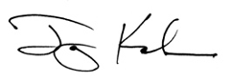______________________________
Jay V. Kahn, Mayor
In City Council September 19, 2024.
Referred to the Municipal Services,
Facilities and Infrastructure Committee.

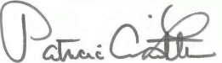
City Clerk

PASSED: October 3, 2024

A true copy, attest: 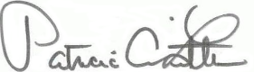
City Clerk

